**COVID VACCINATION CAMP (06.09.2021)**

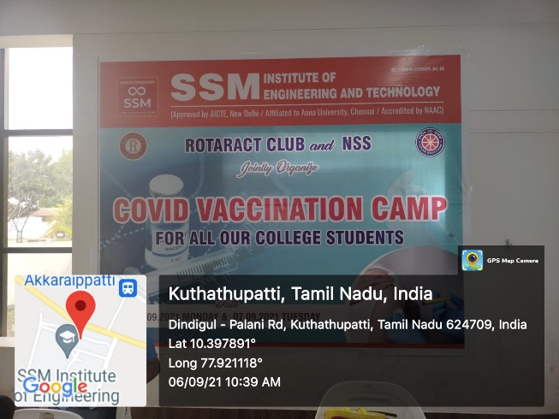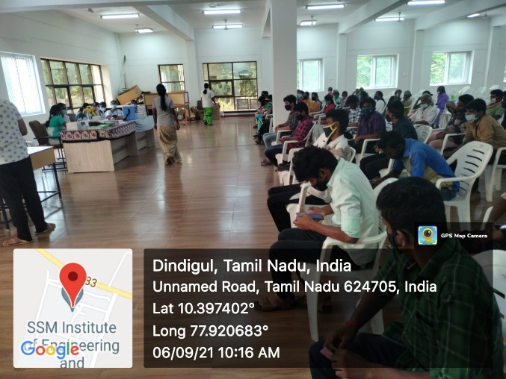

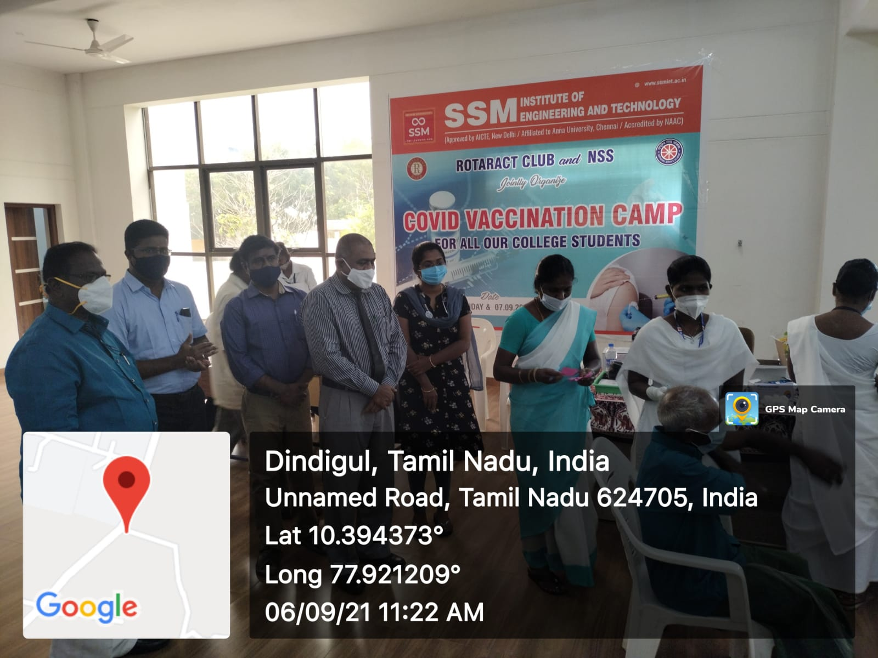

COVID Vaccination Camp was held at SSMIET campus on 06.09.2021 successfully.

We were coordinated this Programme with Rotaract Club, SSMIET, Dindigul. Totally 305 members vaccinated under the NSS / SSMIET.

NSS Coordinator Principal

R.SATHEESH BABU